* At any point in time there will be upwards of 40,000 different option positions available for one single underlying asset. One of the main challenges when investing with option strategies is looking at the list of available options and building the desired strategy in an optimal way.
* The goal of this software is to automate the creation of option strategies by simplifying the input parameters from the user side. It automatically creates all possible strategies of a given type and returns the best possible set of strategies for that given set of parameters. From there the user only has to do basic graphical analysis to pick the best way to position himself in the market.
* Let’s take a look at the software interface:

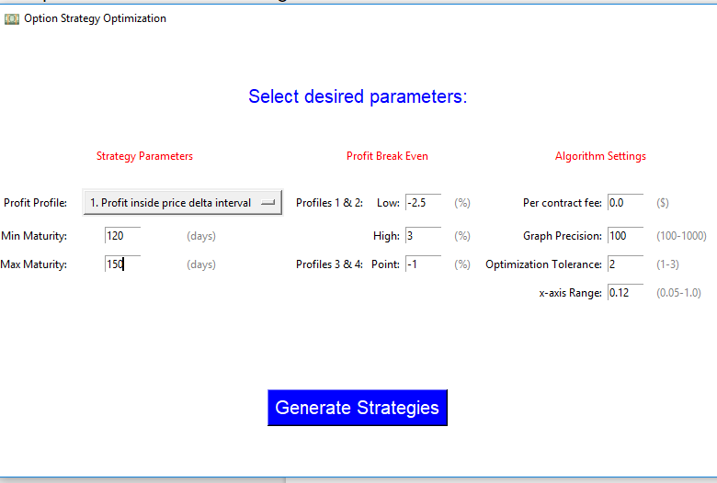

Inputs:

* Profit profile: Here you select the desired profit curve shape. Refer to option strategies for better understanding
* Min maturity: Filters out all strategies that have a maturity lesser than the specified amount (in number of days)
* Max maturity: Filters out all strategies that have a maturity greater than the specified amount (in number of days)
* Because of the way the algorithm is structured it is highly recommended that the difference between max and min maturities is not greater than 30 days
* Profit break even:
  + Profit profiles 1 & 2: low and high are the two break even points of the strategies. The units are specified in % change of the stock price at maturity
  + Profit profiles 3 & 4: desired break even point of the strategies. The units are specified in % change of the stock price at maturity
* Per contract fee: transaction fee charged per contract by the broker
* Graph precision: defines how many points the software will use when constructing the profit graph. The higher the amount, the longer the processing time becomes
* Optimization tolerance: defines the tolerance that the software will have when applying a set of filters to the algorithm. The lower the tolerance the more strict the algorithm will be when taking into account the input parameters. Tolerance can be
  + 1:low
  + 2:medium
  + 3:high
* X-axis range: defines the x-axis range that will be plotted on the strategy profit graphs. This parameter should be set in accordance with the desired break evens.
* Once click Generate Strategies the software will give you a text with information on the strategies:

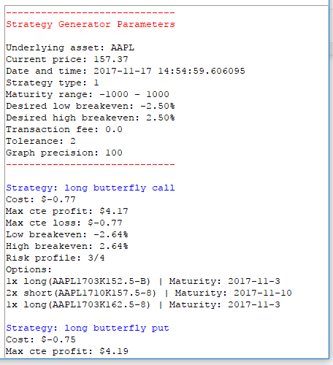

* And also print all the profit curves:

